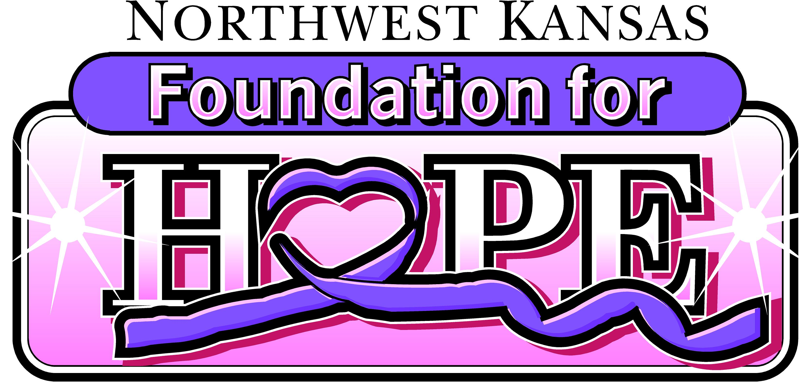

The purpose of the Northwest Kansas Foundation for HOPE is to provide funds to qualified individuals to Help Offset Patient Expenses related to the treatment of cancer. Eligible expenses may include medical expenses not covered by insurance; travel or lodging needs when seeking treatment, wigs or turbans and medication expenses not covered by insurance. Funding is limited.

Grant requests are recommended at $1000 or less.
Application Requirements:
- The applicant must be a resident of Cheyenne, Decatur, Gove, Logan, Rawlins, Sheridan, Sherman, Thomas or Wallace counties;

- The following information must be submitted with the applications:
  - A letter from Physician or Qualified Medical Representative to confirm diagnosis of cancer and type of treatment needed;
  - A listing of expenses, real or projected, for which the grant is being requested;

- Applications with attachments should be mailed to:

Northwest Kansas Foundation for HOPE
PO Box 187
Colby, KS 67701

If you have any questions, please contact a Northwest Kansas Foundation for HOPE committee Member or call 785-443-2896.

Committee Members:

Jennifer Collins Allie Kastens Regina Suter
Roni Dietz Crystal Pounds Lesley Wagoner
Brette Hankin Denni Rehmer Tasha Wagoner
Sara Jamison Alicia Siruta
Jenny Johnson Amber Smith

Revised 02-2020

GRANT APPLICATION

Diagnosis/Type of Cancer

Patient Information:

Name____________________________________________________________ Date of Birth_____________________________

Address________________________________________________________________________________________________

City__________________________________________ State_________________ ZIP___________________ County___________

Phone _________________________________ Phone (Cell)_______________________________________

Email____________________________________________________ SS Number_________________________

Applicant/Contact Person – if different from Patient

Name____________________________________________________________ Date of Birth_____________________________

Address________________________________________________________________________________________________

City__________________________________________ State_________________ ZIP___________________ County___________

Phone _________________________________ Phone (Cell)_______________________________________

Email____________________________________________________

I have been diagnosed with cancer (or am submitting this application on behalf of a minor who has been diagnosed with cancer) and require assistance with costs associated with treatment. I herby give permission to the Committee members of the Northwest Kansas Foundation for HOPE to contact the parties listed in this application or attachments thereto for purposes of verification.

X
X

Date Signature of Applicant

Northwest Kansas Foundation for HOPE ♥ PO Box 187 ♥ Colby, KS 67701-0187 Email: nwks-hope@st-tel.net

AUTHORIZATION TO RELEASE AND/OR RECEIVE CONFIDENTIAL INFORMATION

PATIENT NAME | BIRTH DATE | SOCIAL SECURITY NO.
Patient Address |  | Patient Phone Number
X I HERBY AUTHORIZE ALL OF MY MEDICAL HEALTH PROVIDERS, INCLUDING, BUT NOT LIMITED TO,

TO DISCLOSE PROTECTED HEALTH INFORMATION CONCERNING THE ABOVE-NAMED PATIENT TO: THE NORTHWEST KANSAS FOUNDATION FOR HOPE, ITS OFFICERS, DIRECTORS, AND GRANT MAKING COMMITTEES FOR THE PURPOSE OF DETERMINING THE ELIGIBILITY OF THE PATIENT FOR GRANTS ADMINISTERED BY THE NORTHWEST KANSAS FOUNDATION FOR HOPE.
X X
Patient Signature Date

For Treatment date(s)

Specify date(s) - this line MUST BE COMPLETED
For the following purposes: At the request of patient and for all purposes conned with the above referenced grant request

CHECK TYPE OF INFORMATION AUTHORIZED TO BE USED AND/OR DISCLOSED
(Unless the appropriate box is checked, Provider will not disclose records contained in its medical records prepared by health care providers not affiliated with Provider unless records were prepared on behalf of Provider)
X | Physician letter to confirm diagnosis
This authorization shall remain in effect as long as the above-referenced grant request is pending and while I am receiving the
grant at which time this authorization to disclose the identified health information expires.
I, the undersigned, have read the above and authorize the disclosure of such health information as described herein. I understand that treatment is not conditioned upon the execution of this authorization. I understand that if the person or entity that receives the information is not a health care provider or health plan covered by federal privacy regulations, the information described above may be re-disclosed and no longer protected by
those regulations. I understand that fees may be charged for preparing and sending copies of records as permitted by law. I understand that I may revoke this authorization at any time by providing a written notice to the designated privacy officer of the provider to whom this authorization is
sent. (Note: Revocation is not effective for disclosures that have already been made)
X
X
Date Signature of Patient or Authorized Agent/Representative

Printed Name of Authorized Agent/Representative Authorized Agent/Representative's Relationship to Patient

Address of Authorized Agent/Representative Telephone # of Authorized Agent/Representative

Date Signature of Witness

Northwest Kansas Foundation for HOPE ♥ PO Box 187 ♥ Colby, KS 67701-0187 Email: nwks-hope@st-tel.net

Date

I, have applied for a grant through the Northwest Kansas Foundation For HOPE. I hereby direct any grant monies received to be distributed as follows:
Visa Gift Card

OR

- $ to for .

- $ to for .

- $ to for .

- $200 to Citizens Medical Center for Blood Work (EXAMPLE) .

Due to non-profit status, checks cannot be made payable to recipient.

X

Signature of Applicant

X

Date

Northwest Kansas Foundation for HOPE ♥ PO Box 187 ♥ Colby, KS 67701-0187
Email: nwks-hope@st-tel.net

